Audio Engineering Society

Conference Express Paper

Presented at the AES International Conference on Breaking Barriers in Audio

2025 April 3–5, Virtual

*This Express Paper was selected on the basis of a submitted synopsis that has been peer-reviewed by at least two qualified anonymous reviewers. The complete manuscript was not peer reviewed. This Express Paper has been reproduced from the author’s advance manuscript without editing, corrections, or consideration by the Review Board. The AES takes no responsibility for the contents. This paper is available in the AES E-Library* [*(http://www.aes.org/e-lib),*](http://www.aes.org/e-lib)) *all rights reserved. Reproduction of this paper, or any portion thereof, is not permitted without direct permission from the Journal of the Audio Engineering Society.*

**Very long title of complex audio algorithms and results**

John Smith1, Teri Jones1,2, and John Maclane2

1*First University*

2*Second company*

Correspondence should be addressed to John Smith [(john.smith@fakemail.com)](mailto:(john.smith@fakemail.com)

**ABSTRACT**

Write the abstract here.

# Introduction

Introduce to the topic.

# Methods

Show your methods.

# Results

Present results.

# Discussion

Discuss the results.

# Examples

Here are a few examples on LaTeX.

* 1. **Citations**

Citations can be used as follows, Pulkki [1] created VBAP and DirAC [2]. Notice the difference in the reference types allowed by natbib-package.

* 1. **Equations**

Equations are used often in text and Equation 1 shows an example of this.

cos(2*α*) = *e j*2*π −* 2 sin2(*α*) (1)

* 1. **Tables & figures**

Tables can be created in various ways and for various purposes. The example in Table 1 shows basic trigono- metric values using booktabs formatting.

There are also various ways to include and even draw figures in LaTeX. The most common is to include them.

**Table 1:** This table shows a few trigonometric values.

*θ* sin(*θ* ) cos(*θ* )

*π/*4 *√*2*/*2 *√*2*/*2

*π/*3 *√*3*/*2 1*/*2

*π/*2 1 0

**10**

|  |  |  |  |  |  |  |  |  |
| --- | --- | --- | --- | --- | --- | --- | --- | --- |
|  |  |  |  |  |  |  |  |  |
|  |  |  |  |  |  |  |  |  |
|  |  |  |  |  |  |  |  |  |
|  |  |  |  |  |  |  |  |  |

**5**

**0 **

**dB HL**

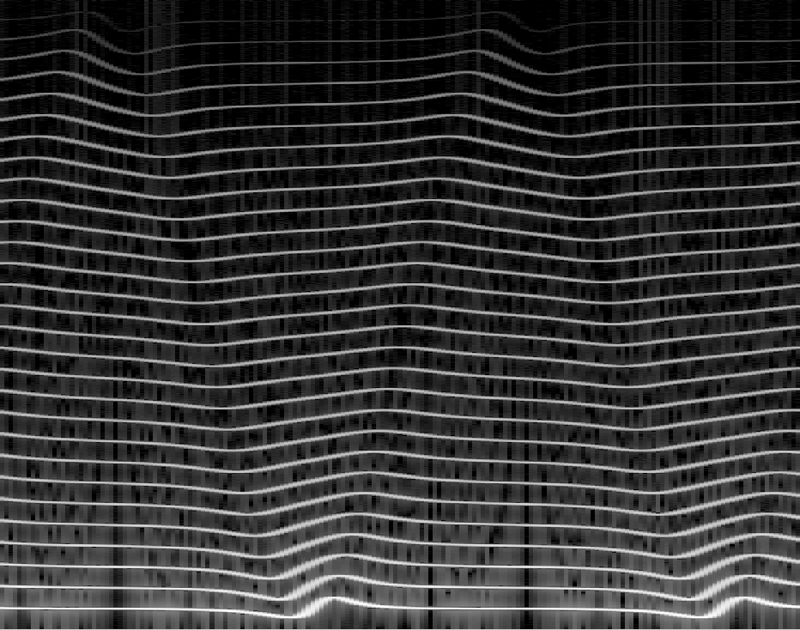

**Fig. 2:** This is a spectrogram of a spectral delay filtered sawtooth waveform using the png format.

**−5**

**−10**

**125 250 500 1k 2k 4k 8k All**

**Frequency**

**Fig. 1:** This is an example of using the pdf format showing means and confidence intervals of au- diometric data.

As is shown with Figures 1 and 2. LaTeX places the figures in the optimal place in the document by its type- setting rules but appropriate location can be hinted with [t], [b], and [h] arguments (corresponding to top, bot- tom, and here). Combination of these are also allowed. AES instructions recommend only placing figures and tables at the top or the bottom of the document but getting the preferred result might require some tuning by hand.

# Summary

Summarize your work and conclude.

Example cites, Pulkki [1] created VBAP and DirAC [2].

Lorem ipsum dolor sit amet, consectetur adipiscing elit. Vestibulum fermentum, libero nec scelerisque condi- mentum, libero mi porta dui, sit amet varius enim dui nec nisi. Suspendisse nulla nibh, lacinia in sapien at,

tempus faucibus dolor. Cum sociis natoque penati- bus et magnis dis parturient montes, nascetur ridiculus mus. Ut facilisis erat accumsan tempor faucibus. Sus- pendisse ac dolor id odio iaculis sodales. Mauris nec arcu non tellus luctus mollis at vitae mi. Curabitur posuere feugiat molestie. Curabitur ac lorem vel arcu gravida volutpat.

Class aptent taciti sociosqu ad litora torquent per conu- bia nostra, per inceptos himenaeos. In lacus est, ac- cumsan non dictum nec, volutpat non justo. Sed auc- tor scelerisque ante, vitae volutpat mauris elementum sit amet. Etiam interdum felis id dignissim imperdiet. Proin ullamcorper sit amet augue quis consequat. Nulla varius enim sed nisl tempus, a ultricies sem finibus. Ut vel purus malesuada, sagittis ligula ut, luctus velit. Sus- pendisse iaculis magna id est consectetur condimentum. Nulla facilisi. Lorem ipsum dolor sit amet, consectetur adipiscing elit. Fusce erat justo, auctor ut malesuada sed, ultrices eu odio. Integer vitae facilisis eros, sed dapibus lacus. Sed eleifend, risus ut congue tincidunt, nulla ipsum vestibulum diam, ut laoreet metus erat auc- tor nunc. Donec nisi diam, aliquam eget pharetra non, viverra non enim.

Integer facilisis elit id mauris laoreet gravida. Etiam dictum auctor nibh, ac pharetra est aliquam et. Praesent a ligula ut turpis egestas cursus vel non ante. Nam varius facilisis urna eget finibus. Duis eleifend dui id lacus tempus aliquet. Praesent vel sodales dolor. Suspendisse potenti.

Curabitur nisi felis, mollis non justo nec, sollicitudin ul- lamcorper lorem. Nunc mattis ullamcorper vestibulum. Aenean vitae turpis vel ipsum porttitor placerat. Etiam quis turpis quis nulla cursus rhoncus. Cum sociis na- toque penatibus et magnis dis parturient montes, nasce- tur ridiculus mus. Sed auctor est sed vehicula dignissim. Sed vel sem eget odio sagittis pharetra ut eu ex. Nullam fermentum ipsum non lacinia sollicitudin. Vestibulum purus ex, volutpat rutrum velit vitae, pulvinar ullamcor- per mi. Maecenas tristique turpis ut justo pellentesque, in hendrerit ligula commodo. Pellentesque eget dignis- sim tellus.

# References

1. Pulkki, V., “Virtual Sound Source Positioning Us- ing Vector Base Amplitude Panning,” *Journal of Audio Engineering Society*, 45(6), pp. 456–466,

1997.

1. Pulkki, V., “Spatial Sound Reproduction with Di- rectional Audio Coding,” *Journal of Audio Engi- neering Society*, 55(6), pp. 503–516, 2007.